Assignment - 1
- Creating and Renaming Files/DIrectories
mkdir test_dir
cd test_dir
touch example.txt
mv example.txt renamed_example.txt
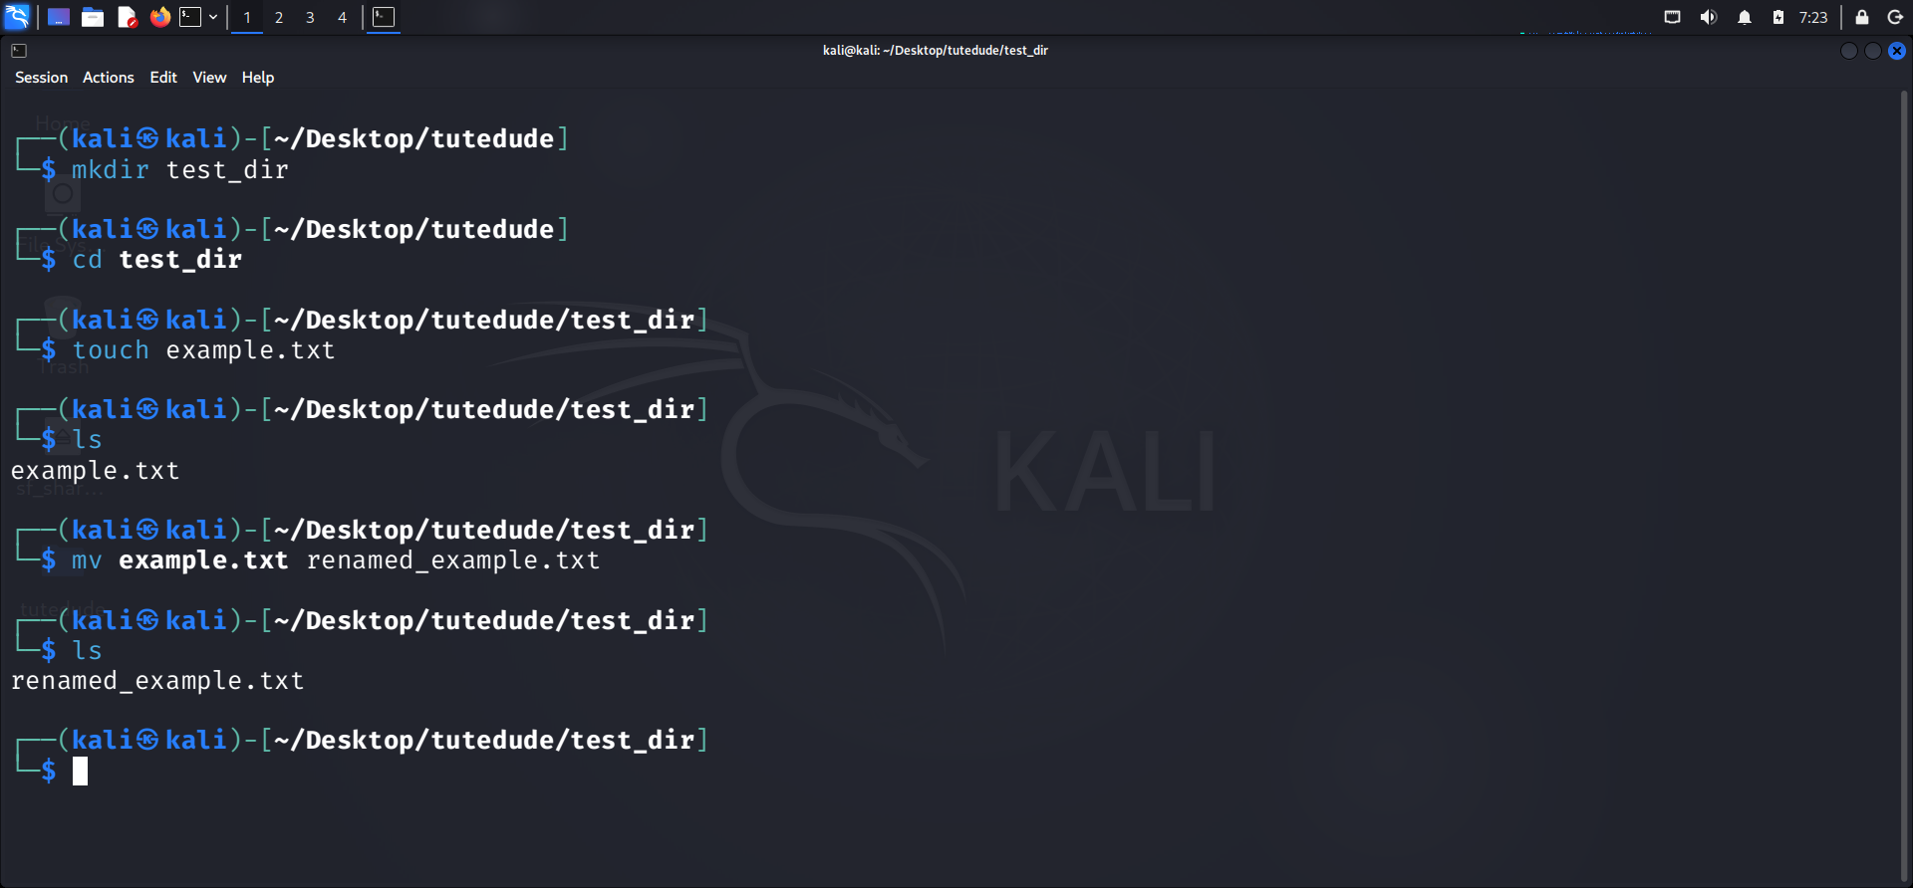

- Viewing file contents
cat /etc/passwd
head -n 5 /etc/passwd
tail -n 5 /etc/passwd
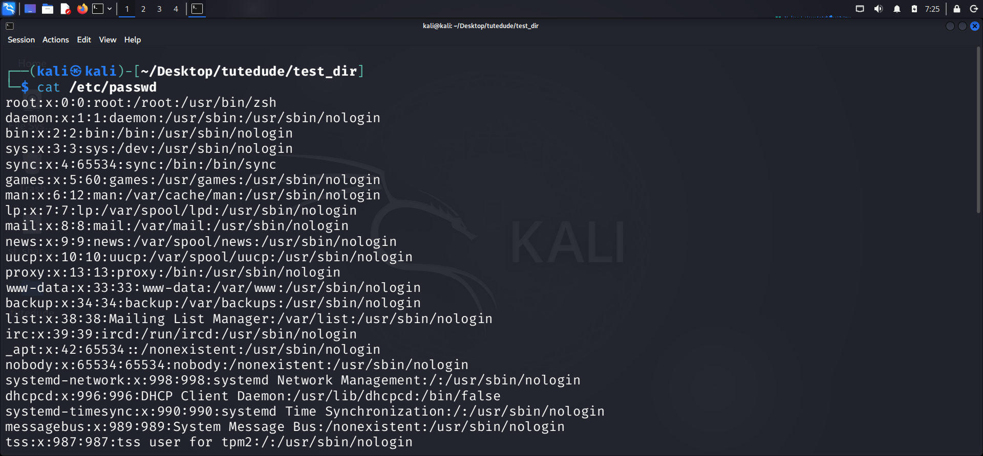
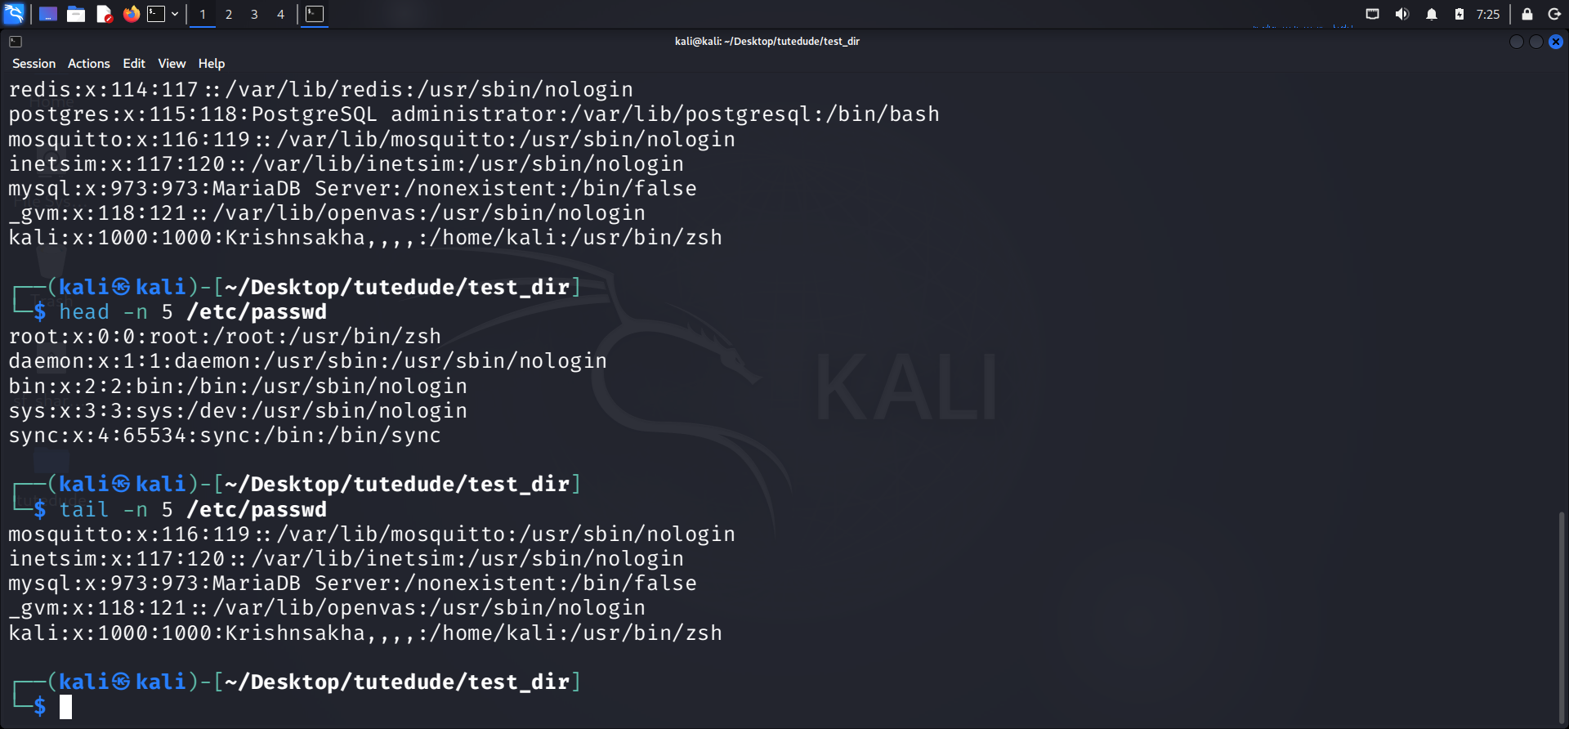

- Searching for Patterns
grep "root" /etc/passwd
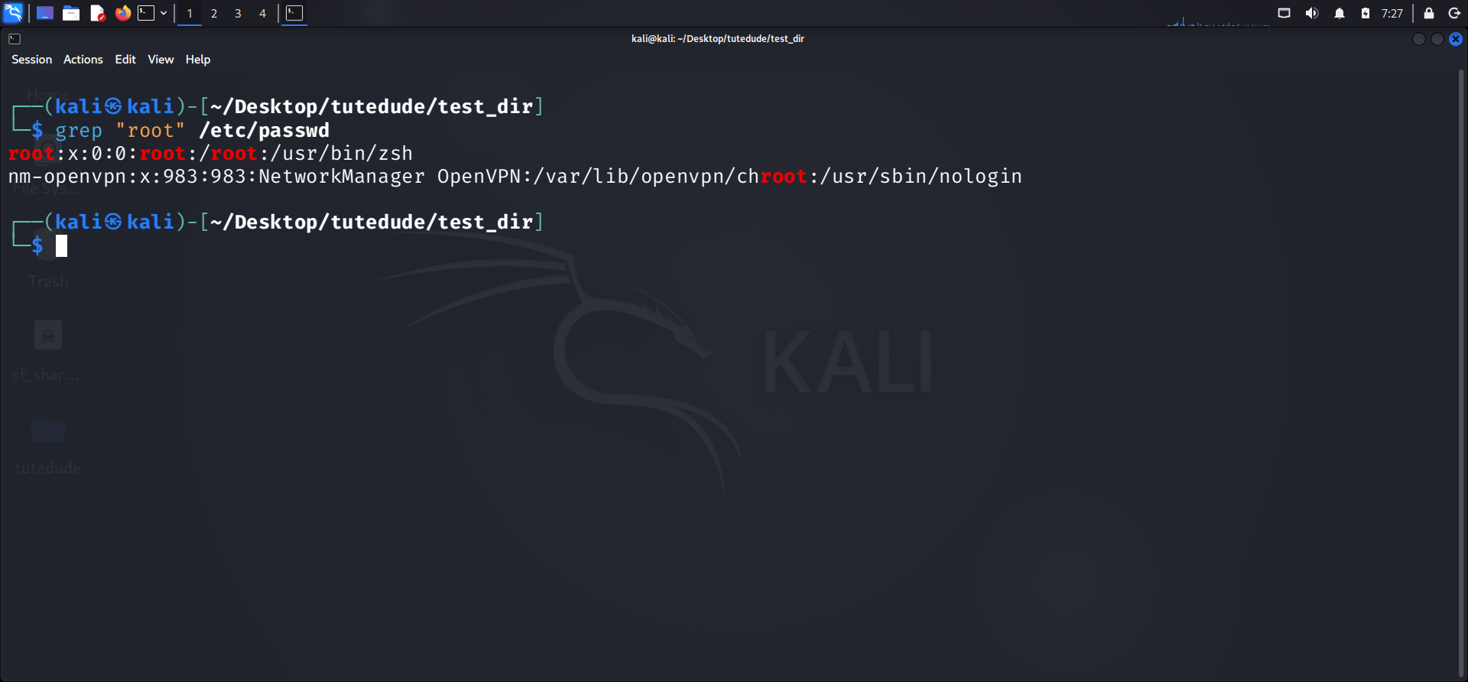

- Zipping and Unzipping
zip test_dir.zip test_dir
unzip test_dir.zip -d unzipped_dir
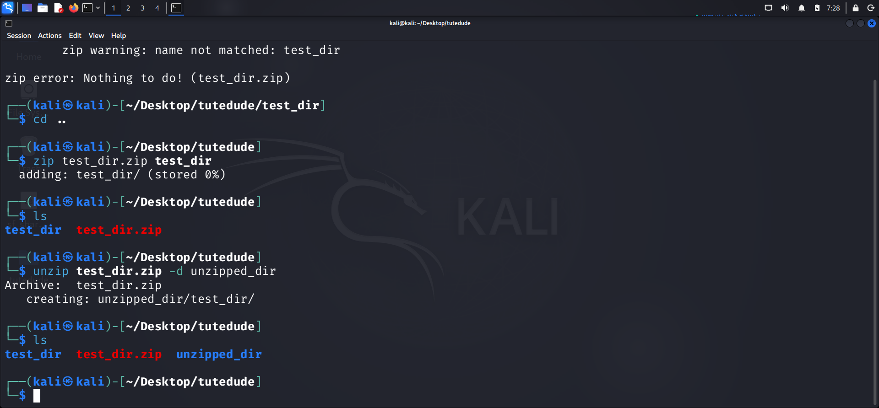

- Downloading Files
wget https://wordpress.org
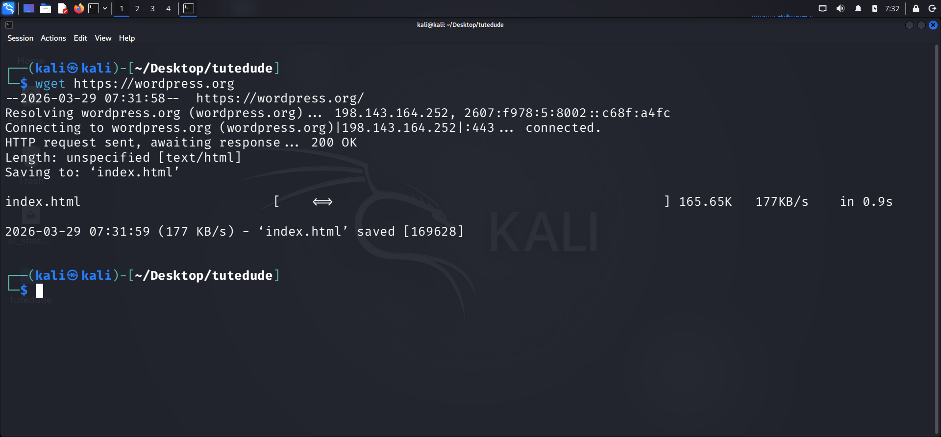
- Changing Permissions
touch secure.txt
chmod a=r secure.txt
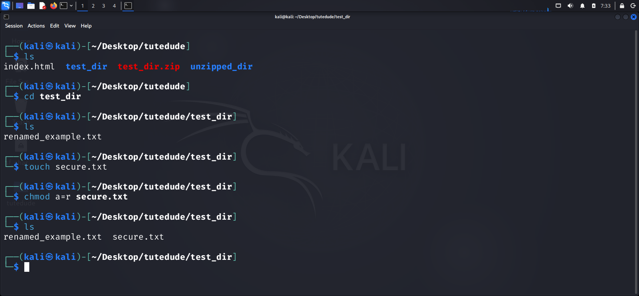

- Working with environment variables
export MY_VAR="Hello Linux!"
